**Homework 3: It’s Query Time!**

The assignment is due on Thursday May 3 at 11:59 pm. Be sure to submit your document to D2L.

Below is a schema for a shoe store. You will use this to create your own SQL statements to create tables, insert data, and issue queries. You are REQIRED to use MySQL to do this assignment. In the event that you are unable to get a SQL statement1 to work, you may submit what you have for partial credit.

The Shoe store’s database schema is as follows:

*Shoes(id, name, description, color1, color2, d_id)*

*CK: name*

*FK: d_id references Department(id)*

*Department(id, name, description)*

*CK: name*

*Orders(id, shoe, size, quantity, has_arrived)*

*FK: shoe references Shoes(id)*

**Step 1 (30 points):** Write create statements for each of the above tables, making sure to have appropriate data types and with all keys declared. To receive full credit, you must have both your exact SQL statement and a screenshot showing the successful executing of your create statements.

Database creation and use:

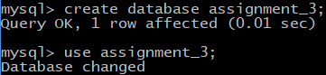

Department table creation:

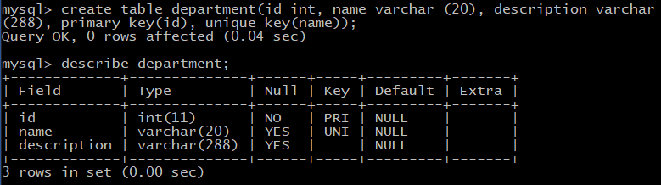

Shoes table creation:

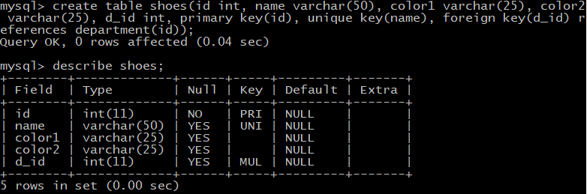

Orders table creation:

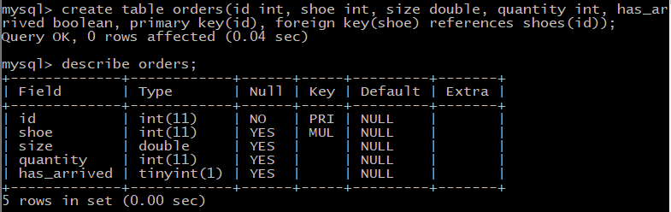

**Step 2 (20 points):** Create insert statements to populate your tables – you get to come up with the data! Make sure you have at least 7 tupples in shoes, 3 in departments, and 15 in orders.

Inserts into department table:

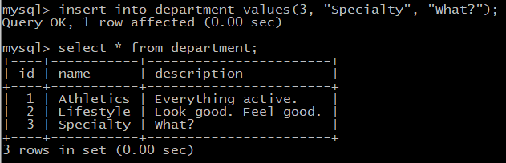

Inserts into shoes table:

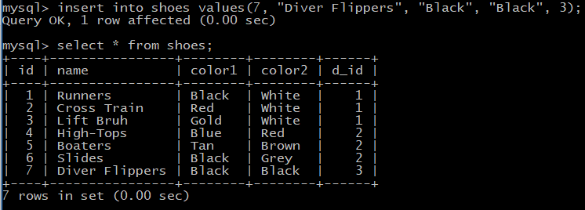

Inserts into orders table:

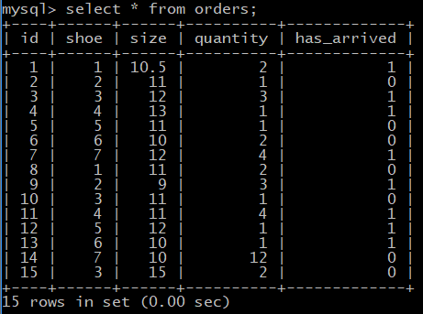

**Step 3 (40 points – 5 points for each query):** Now create select statements to answer the following questions. IMPORTANT: your query must work correctly even if the data in your tables is changed!

1. List all of the information stored in the shoes table.

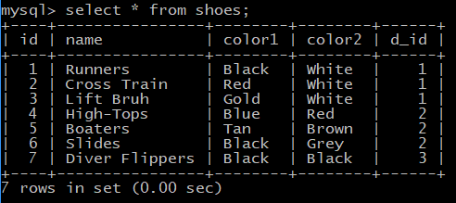

2. List the shoe, size, and quantity for all orders in the Order table.

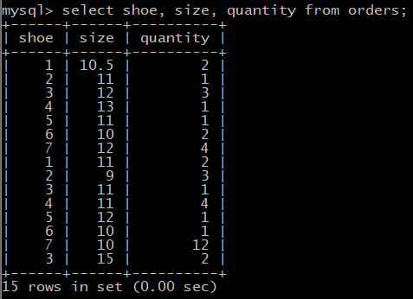

3. List all the order information for shoe orders that have a quantity of at least 2.

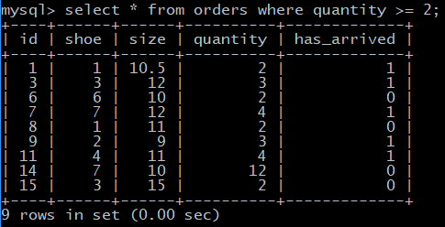

4. Show all shoes that have “blue” as color1 or color2.

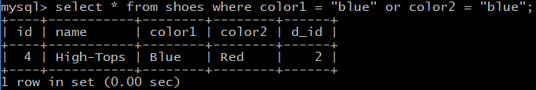

5. For each order that hasn’t arrived yet, show the name of the shoe, it’s description, and the name of its department. (Shoes didn’t have a description? Did colors.)

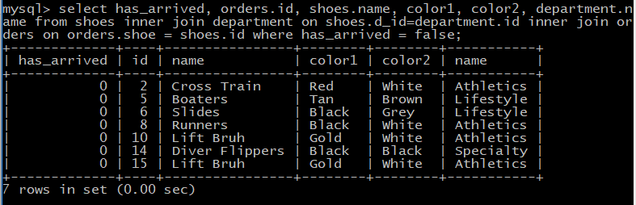

6. Print the number of departments that exist in the database

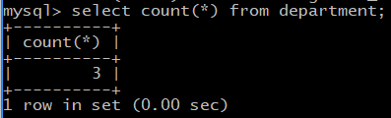

7. For each department, show how many types of shoes exist.

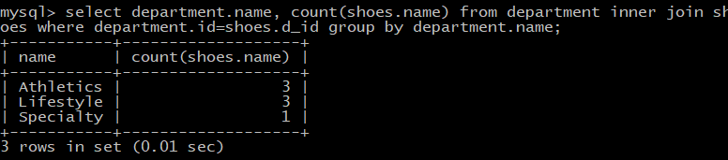

8. Show the total quantity of shoes that have been sold where color1 is red.

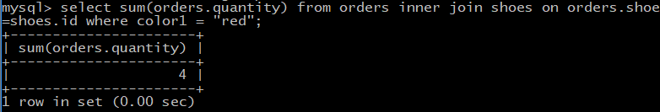

**Step 4 (10 points):**

Reflecting on the material in this chapter and your work on this assignment, what insight does this give you into how databases can power digital dashboards & reports?

Everything is literal, everything should require consistency and naming standards. With that – anything is possible. But seriously. Queries can process incredible amount of selected data. Lots of data can be displayed, sliced, and diced, but a lot of TLC may be required to get your query –



Thank you for including coding in the course work.